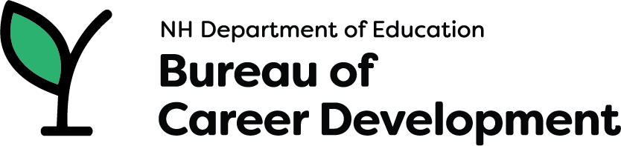

**Mobile Access to Possibilities (M.A.P.s)** mission is to create access to ALL students in New Hampshire, expanding depth of knowledge in Career Technical Education programs, WBL Opportunities and Career Exploration, along with strengthening statewide community partnerships.

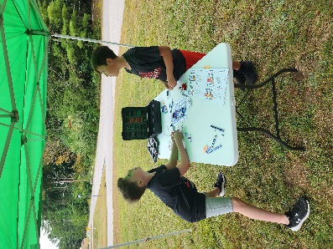

Spend time at the circuit kit and create a circuit that will turn on a light.

Activities are based on the programs that are offered at CTE Centers through out NH.

Z-Space experience – Practice skills to be a welder or auto mechanic.

Work on building a solar robot.

Learn to use construction tools!

Learn about the human body.